DATA PROTECTION PROTOCOL
Guidance: This Data Protection Protocol is for use alongside the NHS terms and conditions. The table at the beginning of the Protocol should be completed by the Authority setting out the nature of the relationship and processing that will be taking place under the Contract.

Table A – Processing, Personal Data and Data Subjects
This Table shall be completed by the Authority, who may take account of the view of the Supplier, however the final decision as to the content of this Table shall be with the Authority at its absolute discretion.

Description | Details
Identity of the Controller and Processor | The Parties acknowledge that they are independent Controllers for the purposes of the Data Protection Legislation.  In respect of Personal Data shared under the Contract in circumstances where the Authority and the Supplier are independent Controllers, Clause 3 of this Protocol will apply.  Both NHS clinical referring centres and homecare providers are independent data controllers. NHS clinical referring centres routinely using (a) Article 6(1)(e) ‘performance of a task carried out in the public interest (public task)’ (for non-special category personal data) and (b) Article 9(2)(h) GDPR for special category personal data as the lawful basis of processing patient data and homecare providers routinely use (a) Article 6(1)(f) GDPR - legitimate interest (for non-special category personal data) and (b) Article 9(2)(h) GDPR for special category personal data as the lawful bases of processing patient data in the provision of clinical and medicines homecare services for NHS patients.  See Annex B – Legal Basis for Data Processing  Patient identifiable data can only be processed for the legitimate interest of delivering the clinical and medicines homecare service which the NHS has commissioned. Whilst legitimate interest is a wide category, the homecare provider can only use the personal data in ways that patients would reasonably expect and this test must be strictly applied where special category data (e.g. health data) is being processed. In practice this means the patient’s personal data will only be used to provide the clinical and medicines homecare service as stated in the clinical referring centres clinical and medicines homecare service information and the homecare provider’s welcome pack.
Subject matter of the  Processing | Processing of personal data, including sensitive personal data, for the purpose of dispensing and delivering pharmaceutical products and, where required, associated clinical services (e.g. injection training and medication administration) to the patients’ home or alternative appropriate location. Personal data processed may include personal information of patients’ friends, family and carers.
Duration of the  Processing | Processing shall start on the commencement date and shall continue for the term of the Contract. The Supplier shall maintain its obligations as a data controller for the specified datasets following termination of the Contract.  Individual patient data processing commences upon the submission of a completed registration form by the Authority to the Supplier. Following completion of registration onto the service by the Supplier, processing shall continue for the duration the patient remains on service.  Following a patients’ removal from service processing for the purpose of archiving shall continue in accordance with the retention of records table set out in Annex A.
Nature and purposes of  the Processing | The purpose of processing is to provide a safe and effective homecare medicines service as defined the Royal Pharmaceutical Society Professional Standards for Homecare.  The nature of the processing is set out in Annex B and is aligned with the guidance set out in “Impact of the General Data Protection Regulation in Clinical and Medicines Homecare Service” https://www.clinicalhomecare.org/wp-content/uploads/2019/01/NCHA-Position-statement_GDPR_v1.1_190115_FinalFinal.pdf as reviewed by the Information Commissioners Office and endorsed by the National Homecare Medicines Committee.  On completion of the patient registration process and for data which the Supplier has a legal or regulatory obligation to maintain, the Supplier shall create a replicate data set of certain data on the patient registration form and shall become a data controller in respect of such data which they replicate and subsequently collect directly. The purpose of the data processing by the Supplier is at all times, including following expiry or termination of the Contract, limited to provision of services detailed within this Contract or any other purpose strictly necessary to fulfil a legal obligation.
Type of Personal Data being Processed | Patient demographic data, contact information, location data, relevant clinical data. See Annex B.
Categories of Data  Subject | Patient, carer, parent / guardian, patient friends & family (in relation to service delivery to the patient). See Annex B.
Plan for return and destruction of the data once the Processing is complete  UNLESS requirement under union or member state law to preserve that type of data | Data processed by the Supplier shall be held in accordance with the retention of records table in Annex A and shall only be retained beyond such periods if there is a legitimate reason for doing so.
Definitions
The definitions and interpretative provisions at Schedule 4 (Definitions and Interpretations) of the Contract shall also apply to this Protocol. For example, the following terms are defined in Schedule 4 of the Contract: “Authority”, “Controller”, “Process” and “Processer” and “Supplier” are defined in Schedule 4 of the Contract. Additionally, in this Protocol the following words shall have the following meanings unless the context requires otherwise:

“Data Loss Event” | means any event that results, or may result, in unauthorised access to Personal Data held by the Processor under this Contract, and/or actual or potential loss and/or destruction of Personal Data in breach of this Contract, including any Personal Data Breach;
“Data Protection Legislation” | means (i) the GDPR, the LED and any applicable national implementing Laws as amended from time to time (ii) the DPA 2018 to the extent that it relates to Processing of personal data and privacy; (iii) all applicable Law about the Processing of Personal Data and privacy;
“Data Protection Impact Assessment” | means an assessment by the Controller of the impact of the envisaged Processing on the protection of Personal Data;
“Data Protection Officer” | shall have the same meaning as set out in the GDPR;
“Data Recipient” | means that Controller who receives the relevant Personal Data;
“Data Subject” | shall have the same meaning as set out in the GDPR;
“Data Subject Request” | means a request made by, or on behalf of, a Data Subject in accordance with rights granted pursuant to the Data Protection Legislation to access their Personal Data;
“Data Transferor” | means that Controller who transfers the relevant Personal Data;
“DPA 2018” | means the Data Protection Act 2018;
“Homecare Medicines Services” | means a service that delivers ongoing medicine supplies and, where necessary, associated care, initiated by the hospital prescriber, direct to the patient’s home with their consent. The purpose of the homecare medicines service is to improve patient care and choice of their clinical treatment.
“Joint Controllers” | means where two or more Controllers jointly determine the purposes and means of Processing;
“LED” | means the Law Enforcement Directive (Directive (EU) 2016/680);
“Patient” | means the individual receiving the homecare medicines service or the patient’s carer, friends and family.
“Personal Data Breach” | shall have the same meaning as set out in the GDPR;
“Protective Measures” | means appropriate technical and organisational measures which may include: pseudonymising and encrypting Personal Data, ensuring confidentiality, integrity, availability and resilience of systems and services, ensuring that availability of and access to Personal Data can be restored in a timely manner after an incident, putting in place appropriate training of staff involved in the processing of Personal Data and regularly assessing and evaluating the effectiveness of such measures adopted by it.
“Protocol” or “Data Protection Protocol” | means this Data Protection Protocol;
“Sub-processor” | means any third Party appointed to Process Personal Data on behalf of a Processor related to this Contract.

- SUPPLIER AS DATA PROCESSOR
  - Where, in Table A, the Parties acknowledge that for the purposes of the Data Protection Legislation, the Authority is the Controller and the Supplier is the Processor for the relevant purposes specified in Table A this Clause 1 shall apply. The only Processing that the Supplier is authorised to do is listed in Table A of this Protocol by the Authority and may not be determined by the Supplier.
  - The Supplier shall notify the Authority immediately if it considers that any of the Authority’s instructions infringe the Data Protection Legislation.
  - The Supplier shall provide all reasonable assistance to the Authority in the preparation of any Data Protection Impact Assessment prior to commencing any Processing. Such assistance may, at the discretion of the Authority, include:
    - a systematic description of the envisaged Processing operations and the purpose of the Processing;
    - an assessment of the necessity and proportionality of the Processing operations in relation to the Services;
    - an assessment of the risks to the rights and freedoms of Data Subjects; and
    - the measures envisaged to address the risks, including safeguards, security measures and mechanisms to ensure the protection of Personal Data.
  - The Supplier shall, in relation to any Personal Data Processed in connection with its obligations under this Contract:
    - Process that Personal Data only in accordance with Table A, unless the Supplier is required to do otherwise by Law. If it is so required the Supplier shall promptly notify the Authority before Processing the Personal Data unless prohibited by Law;
    - ensure that it has in place Protective Measures, which are appropriate to protect against a Data Loss Event, which the Authority may reasonably reject (but failure to reject shall not amount to approval by the Authority of the adequacy of the Protective Measures), having taken account of the:
      - nature of the data to be protected;
      - harm that might result from a Data Loss Event;
      - state of technological development; and
      - cost of implementing any measures;
    - ensure that :
      - the Supplier Personnel do not Process Personal Data except in accordance with this Contract (and in particular Table A);
      - it takes all reasonable steps to ensure the reliability and integrity of any Supplier Personnel who have access to the Personal Data and ensure that they:
        - are aware of and comply with the Supplier’s duties under this Protocol;
        - are subject to appropriate confidentiality undertakings with the Supplier or any Sub-processor;
        - are informed of the confidential nature of the Personal Data and do not publish, disclose or divulge any of the Personal Data to any third Party unless directed in writing to do so by the Authority or as otherwise permitted by this Contract; and
        - have undergone adequate training in the use, care, protection and handling of Personal Data;
    - not transfer Personal Data outside of the UK (or the EU for so long as the UK remains a member of the EU or the member states of the EU are the subject of an UK adequacy decision) unless the prior written consent of the Authority has been obtained and the following conditions are fulfilled:
      - the Authority or the Supplier has provided appropriate safeguards in relation to the transfer (whether in accordance with GDPR Articles 45 or 46 or LED Article 37) as determined by the Authority;
      - the Data Subject has enforceable rights and effective legal remedies;
      - the Supplier complies with its obligations under the Data Protection Legislation by providing an adequate level of protection to any Personal Data that is transferred (or, if it is not so bound, uses its best endeavours to assist the Authority in meeting its obligations); and
      - the Supplier complies with any reasonable instructions notified to it in advance by the Authority with respect to the Processing of the Personal Data; and
    - at the written direction of the Authority, delete or return Personal Data (and any copies of it) to the Authority on termination of the Contract unless the Supplier is required by Law to retain the Personal Data.
  - Subject to Clause 1.6 of this Protocol, the Supplier shall notify the Authority immediately if in relation to any Personal Data Processed in connection with its obligations under this Contract it:
    - receives a Data Subject Request (or purported Data Subject Request);
    - receives a request to rectify, block or erase any Personal Data;
    - receives any other request, complaint or communication relating to either Party’s obligations under the Data Protection Legislation;
    - receives any communication from the Information Commissioner or any other regulatory authority in connection with Personal Data Processed under this Contract;
    - receives a request from any third party for disclosure of Personal Data where compliance with such request is required or purported to be required by Law; or
    - becomes aware of a Data Loss Event.
  - The Supplier’s obligation to notify under Clause 1.5 of this Protocol shall include the provision of further information to the Authority in phases, as details become available.
  - Taking into account the nature of the Processing, the Supplier shall provide the Authority with full assistance in relation to either Party’s obligations under Data Protection Legislation in relation to any Personal Data Processed in connection with its obligations under this Contract and any complaint, communication or request made under Clause 1.5 of this Protocol (and insofar as possible within the timescales reasonably required by the Authority) including by promptly providing:
    - the Authority with full details and copies of the complaint, communication or request;
    - such assistance as is reasonably requested by the Authority to enable the Authority to comply with a Data Subject Request within the relevant timescales set out in the Data Protection Legislation;
    - the Authority, at its request, with any Personal Data it holds in connection with its obligations under this Contract in relation to a Data Subject;
    - assistance as requested by the Authority following any Data Loss Event;
    - assistance as requested by the Authority with respect to any request from the Information Commissioner’s Office, or any consultation by the Authority with the Information Commissioner’s Office.
  - The Supplier shall maintain complete and accurate records and information to demonstrate its compliance with this Protocol. This requirement does not apply where the Supplier employs fewer than 250 staff, unless:
    - the Authority determines that the Processing is not occasional;
    - the Authority determines the Processing includes special categories of data as referred to in Article 9(1) of the GDPR or Personal Data relating to criminal convictions and offences referred to in Article 10 of the GDPR; or
    - the Authority determines that the processing is likely to result in a risk to the rights and freedoms of Data Subjects.
  - The Supplier shall allow for audits of its data Processing activity by the Authority or the Authority’s designated auditor in relation to any Personal Data Processed in connection with its obligations under this Contract.
  - Each Party shall designate its own Data Protection Officer if required by the Data Protection Legislation.
  - Before allowing any Sub-processor to Process any Personal Data related to this Contract, the Supplier must:
    - notify the Authority in writing of the intended Sub-processor and Processing;
    - obtain the written consent of the Authority;
    - enter into a written agreement with the Sub-processor which give effect to the terms set out in this Protocol such that they apply to the Sub-processor; and
    - provide the Authority with such information regarding the Sub-processor as the Authority may reasonably require.
  - The Supplier shall remain fully liable for all acts or omissions of any of its Sub-processors.
  - The Authority may, at any time on not less than 30 Business Days’ notice, revise this Protocol by replacing it with any applicable controller to Processor standard clauses or similar terms forming part of an applicable certification scheme (which shall apply when incorporated by attachment to this Contract).
  - The Parties agree to take account of any guidance issued by the Information Commissioner’s Office. The Authority may on not less than 30 Business Days’ notice to the Supplier amend this Protocol to ensure that it complies with any guidance issued by the Information Commissioner’s Office.
  - The Supplier shall comply with any further instructions with respect to Processing issued by the Authority by written notice. Any such further written instructions shall be deemed to be incorporated into Table A from the date at which such notice is treated as having been received by the Supplier in accordance with Clause 27.2 of Schedule 2 of the Contract.
- PARTIES AS JOINT CONTROLLERS
  - Where in, Table A, the Parties acknowledge that for the purposes of the Data Protection Legislation, the Authority and the Supplier are Joint Controllers this Clause 2 shall apply.
  - The only Processing that a Joint Controller is authorised to do is listed in Table A of this Protocol by the Authority and may not be determined by the Supplier.
  - The Parties shall in accordance with GDPR Article 26 enter into a Joint Controller Agreement based on the terms outlined in Schedule 1 (removed as not applicable for typical homecare medicines service).
- BOTH DATA CONTROLLERS
  - To the extent that the nature of the Services means that the Parties are acting both as Controllers (as may be referred to in Table A), each Party undertakes to comply at all times with its obligations under the Data Protection Legislation and shall:
    - implement such measures and perform its obligations (as applicable) in compliance with the Data Protection Legislation;
    - be responsible for determining its data security obligations taking into account the state of the art, the costs of implementation and the nature, scope, context and purposes of the Processing as well as the risk of varying likelihood and severity for the rights and freedoms of the Data Subjects, and implement appropriate technical and organisational measures to protect the Personal Data against unauthorised or unlawful Processing and accidental destruction or loss and ensure the protection of the rights of the Data Subject, in such a manner that Processing will meet the requirements of the Data Protection Legislation where Personal Data has been transmitted by it, or while the Personal Data is in its possession or control;
    - where appropriate, promptly refer to the other Party any requests, from (i) Data Subjects in regards to the right of access to Personal Data by that Data Subject in accordance with the Data Protection Legislation; (ii) the Information Commissioner; or (iii) any other law enforcement authority and to the extent it is reasonable and practical to do so consult with the other Party (for the avoidance of doubt at no additional cost) before responding to such request.
  - Where Personal Data is shared between the Parties, each acting as Controller:
    - the Data Transferor warrants and undertakes to the Data Recipient that such Personal Data have been collected, Processed and transferred in accordance with the Data Protection Legislation and this Clause 3;
    - the Data Recipient will Process the Personal Data in accordance with the Data Protection Legislation and this Clause 3; and
    - where the Data Recipient is in breach of its obligations under this Protocol and the Data Protection Legislation, the Data Transferor may temporarily suspend the transfer of the Personal Data to the Data Recipient until the breach is repaired.

Guidance: there are limited requirements in the GDPR when parties act as separate Controllers. Clause 3 above provides a sensible starting point. However, Authorities are advised to review the Information Commissioner’s Guidance (ICO GDPR Guidance) and consultant their Information Governance team when considering whether further provisions or a separate data sharing agreement should be used.

- CHANGES TO THIS PROTOCOL
  - Subject to Clauses 1.13, 1.14 and 1.15 of this Protocol, any change or other variation to this Protocol shall only be binding once it has been agreed in writing and signed by an authorised representative of both Parties.

Annex A – Retention of Records
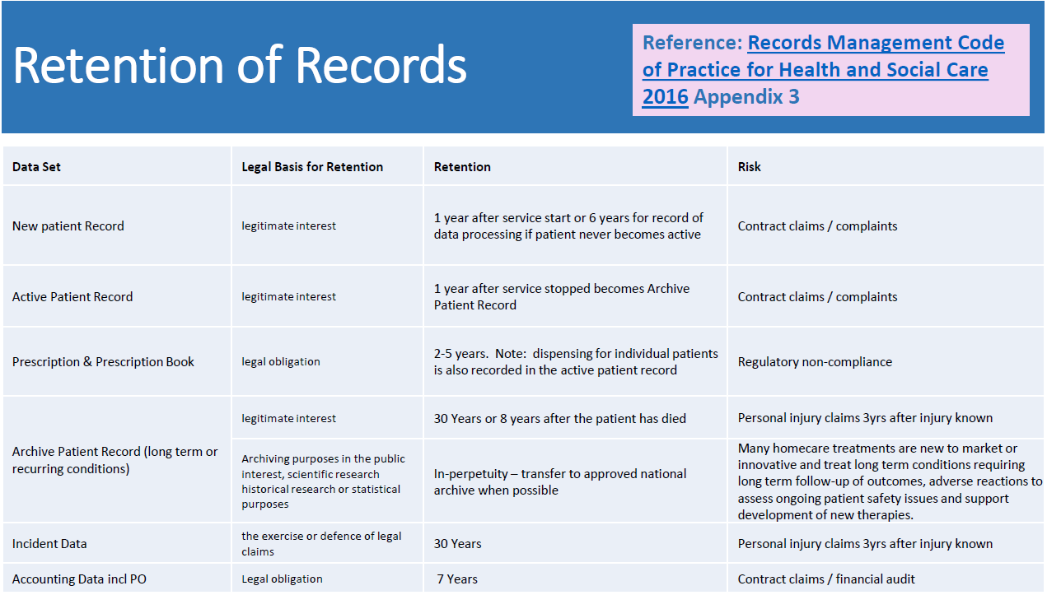

Annex B – Data maps
