- Glossary of terms
Cool Box: Validated medical grade cool boxes and cool packs from a recognised medical supply company, used in conjunction with validated maximum–minimum thermometers. If the cool box is intended to be used for storage with repeated removal of vaccines, the cool box validation must take this into account.
End user location: A location within the same PCN geography where the administration of vaccine takes place e.g. care home
Foundry: a web-based stock control system that is used at PCN Designated Site.
Lead GP: Lead doctor at the PCN Designated Site responsible for the safe and secure handling and management of medicines within the site.
Nominated Responsible Person: named and suitably trained team member at each vaccination site who has been delegated operational responsibility for oversight of ordering, receipt, storage and safe handling of vaccines and medicines by the Lead GP aided by the Primary Care Lead Pharmacist.
PCN Designated Site: An approved local vaccination site that meets the core requirements for COVID-19 vaccination according to the Enhanced Service Specification.
Primary Care Lead Pharmacist: the pharmacist lead for a locality in primary care, as agreed by the Regional Chief Pharmacist and often being the CCG lead pharmacist, who is responsible for supporting the Lead GP to deliver the governance requirements.
Suitably trained members of staff: Staff that have completed the requisite national training and been assessed as competent to undertake the task.

- Purpose

This SOP describes the process for preparation of ready to administer syringes of AstraZeneca COVID-19 Vaccine (ChAdOx1 S [recombinant]) prior to immediate administration.
- Scope

This procedure covers the process from the removal of vials of vaccine from the outer carton in the refrigerator or cool box up until the point of administration. This includes the preparation of syringes for administration and assigning an expiry date and time after the first dose withdrawal.

This procedure may be adapted to suit either of the following models:
- One person performing the entire process. If the vaccine is being administered under the national Patient Group Direction (PGD) the same healthcare professional must, for each individual receiving the vaccine, undertake all stages of the process including administration of the vaccine. See section 8.1 for more details on working under a PGD.
- One person drawing up individual doses into syringes and passing the syringe to the vaccinator. The national protocol allows this model. This model requires additional local risk assessment, and the introduction of local controls to reduce the risk of needle stick injuries on transfer between individuals.

- Responsibility

Suitably trained members of staff performing any stage of the preparation of the vaccine are responsible for following this procedure.
The Lead GP and Primary Care Lead Pharmacist must ensure that appropriate and formal authorisation for vaccine administration is in place such as a Patient Group Direction or national protocol and that the staff groups who are supplied with the vaccine are those defined as eligible to do so. Staff working under these mechanisms must understand their responsibilities.
When working in pairs, it is the responsibility of both people to continue to observe all local COVID-19 precautions.

- Procedure
Within this procedure when the term refrigerator/fridge is used, at end user locations this means a validated cool box

  - Workstation preparation

    - Confirm the preparation workstation is clear and free from any other vials of vaccine.
    - Ensure a yellow lidded sharps bin with sufficient free capacity is available.
    - Ensure indelible pen is available
    - Put on apron
    - Clean workstation with a disinfectant wipe and discard into a clinical waste bin.
    - [Insert statement on local practice for sanitising hands / donning gloves for preparing injectable medicines]

  - Removal of vaccines from the refrigerator

    - Remove the required number of vaccine vials from the original carton in the refrigerator.
    - If there is more than one batch of vaccine vials, use the one with the shortest expiry. One vial contains sufficient vaccine for 8 doses (4ml) or 10 doses (5ml) depending on presentation received.

  - Withdrawal into syringes
Work with one vaccine vial at any one time.
    - Gather the following materials required to prepare syringes:
      - AstraZeneca COVID-19 Vaccine vial X 1
      - 1ml syringe with integrated 23g x 25mm needle X 8 or 10
N.B. A 21g x 38mm or 23g x 38mm needle and 1ml syringe should be used for administering the vaccine to morbidly obese patients. These are available to order via the Immform system.
      - Sterile single use 70% alcohol swab X 8 or 10
[NB: An additional syringe/needle and alcohol swab will be required if local policy is to withdraw 9 or 11 doses (see section 5.3.11 for information about a 9th or 11th dose)]

    - After first dose withdrawal, use the vial as soon as practically possible and within 6 hours (stored at 2°C to 25°C). Document the expiry date and time (24 hour format, e.g. 1400) on the vial after first use.

    - Obtain a second check that the correct vaccine has been selected, by confirming the product name on the vial(s), and the expiry date and time is correct. The second person should document this check by signing the label [2nd check depending on local policy and setting]

    - The vaccine vial is a colourless to slightly brown, clear to slightly opaque solution. Visually inspect the vial prior to administration and discard if particulate matter or differences in the described appearance are observed. Do not shake the vial.

    - Cleanse the vial stopper with a single use 70% alcohol swab, and discard swab in a clinical waste bin.

    - Using aseptic technique, draw up 0.5mL of the vaccine using a new 1ml syringe with integrated 23g (or 25g) x 25mm needle.
N.B.23g x 38mm needles and 1ml syringes are available for morbidly obese patients.
    - Adjust to remove air bubbles with the needle still in the vial to avoid loss of vaccine.

    - Check volume withdrawn is 0.5mL. [May require independent 2nd check depending on local policy]

    - Visually inspect the syringes for particles and leaks. Discard if these are observed.

    - The newly filled syringe must be used for immediate administration. [Local risk assessment required to manage risk of needle stick injury]

    - Steps 5.3.4 to 5.3.10 may be repeated a further seven or nine times to produce a total of eight or ten syringes from each vaccine vial. Each time the vial bung is punctured, this should be in a different location to previous points of puncture on the bung. It is normal for liquid to remain in the vial after withdrawing the final dose. When low dead volume syringes and/or needles are used, the amount remaining in the vial may be sufficient for an additional dose. Care should be taken to ensure a full 0.5ml dose is administered. Where a full 0.5ml dose cannot be extracted, the remaining volume should be discarded. Do not pool excess vaccine from multiple vials.

    - Update the stock management system on Foundry.

    - Once all the required doses have been withdrawn or if expiry has been exceeded, discard the used vaccine vial into a yellow lidded sharps bin.

    - At the end of the session, any vials that have had doses withdrawn must be discarded into a yellow lidded sharps bin.

    - If unused vaccine vials have left the PCN Designated site for administration elsewhere, they must not be returned to stock. Discard the vaccine vials into a yellow lidded sharps bin.

    - All waste must be handled in such a way as to prevent theft and misuse both on site and after removal from the site. Waste vaccines and empty vials must be placed into the clinical or medicinal waste stream according to normal local waste management procedures. Outer cartons must have their labels defaced using permanent black marker pens, and must be disposed of via the confidential waste stream. Alternatively, packaging must be stored in a secure container(s) and shredded on-site.

  - Dealing with deviations from this procedure
    - Any deviations from this procedure must be reported to the Nominated Responsible Person who can then escalate to the Primary Care Lead Pharmacist or Lead GP.
    - Where vaccine is discarded, information must be reported on Foundry with the following codes:
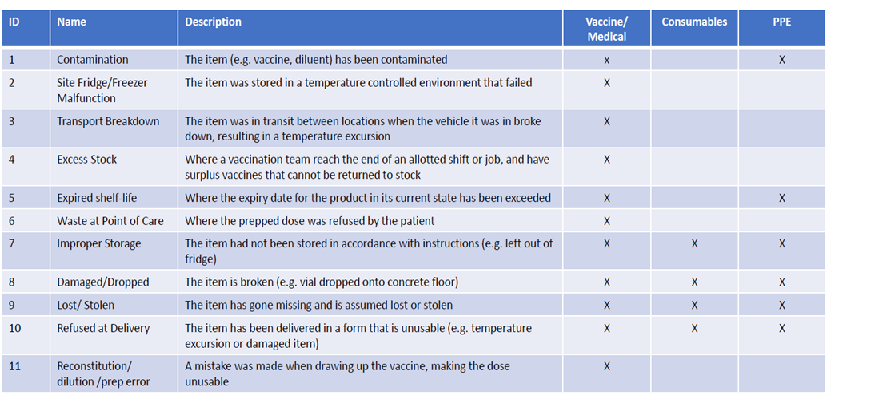
- Document history
Date | Version | Section | Details
06.01.2021 | 1.1 | 1 | Definition of end user location added
06.01.2021 | 1.1 | 5.3.15 | Added instruction to discard unused vials that have left PCN Designated Site
07.01.2021 | 1.2 | 5.3.11 | Reference to section 8.3 about additional dose
07.01.2021 | 1.2 | 8.1 | Additional link added
07.01.2021 | 1.2 | 8.3 | Withdrawing additional doses information added
22.01.2021 | 1.3 | 3 | Clarification on undertaking all steps of the process when working under the national PGD. Also wording now reflects availability of National Protocol
22.01.2021 | 1.3 | 5.3.1 | Additional consumables for 9th or11th dose added
22.01.2021 | 1.3 | 5.3.3 | Addition of 2nd check to include correct vaccine vial selected
22.01.2021 | 1.3 | 5.3.6 | Now states “new” syringe / needle must be used
22.01.2021 | 1.3 | 5.3.11 | Previous section 8.3 on additional doses moved into this section
22.01.2021 | 1.3 | 8.3 | Deleted and content moved to 5.3.11
02.02.21 | 1.4 | 5.2.1 | Clarification of wording about removing of vaccine vials from refrigerator.
02.02.21 | 1.4 | 5.3.1 | Amended needle gauge options for morbidly obese patients in accordance with PHE guidance
02.02.21 | 1.4 | 5.3.11 | Avoidance of pooling vaccines added
12.02.21 | 1.5 | 5.3.16 | Clarification of waste disposal advice to prevent theft and misuse
12.02.21 | 1.5 | 5.3.17 | Removed and incorporated into 5.3.16
19.03.21 | 1.6 | 5.3.16 | Further clarification of waste disposal advice to prevent theft and misuse

- Supporting Documents
AVH3.1 – AstraZeneca COVID-19 Vaccine preparation work instruction
AVH3.2 - Vaccine Supervision Checklist

- Further information
  - Working under a PGD
There can be no delegation of any stage within the PGD so everything from clinical assessment, consent, through vaccine preparation and administration to record keeping has to be undertaken by the same registered healthcare professional working under the PGD.
Further information can be found at Patient Group Directions for the COVID-19 vaccines: Summary and
Delegation of supply or administration of medicines using a PGD

  - Storage conditions
At the time of writing there is no further stability information in addition to that included within the Regulation 174 document for the AstraZeneca COVID-19 vaccine.

